Year 3 of 4 | Primary |  | Autumn Term |  | Spring Term |  | Summer Term
Theme |  |  | Into the Woods | Pirates | To the Rescue | Europe | Splash | Journeys
Independent Living |  | My Independence  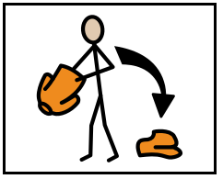 | Topic:  Dressing and Undressing  Intent:  Hygiene, clean and dirty clothes |  | Topic:  Travel  Intent:  Crossing roads |  | Topic:  Shopping  Intent:  Types of shops
 |  | Cooking  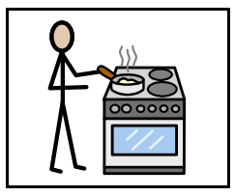 | Topic:  Recap on cutting/Grating Introduce Germs and Bacteria  Intent:  Understanding food hygiene | Topic:  Pies  Intent:  Peeling | Topic:  Healthy snacks  Intent:  Understanding of heathy and unhealthy | Topic:  Smoothies  Intent:  Blending | Topic:  Microwave  Intent:  Understanding temperature | Topic:  Bread  Intent:  Kneading
Education  +  Employment |  | Communication and  Language   | Fairy Tales | Poems, Songs and Rhymes | Science Fiction | Non-Fiction/ Fact Files | Fiction | Fables
Ensure the following is delivered daily
Reading and Writing: Individualised targets taught in the moment/in context from STAR Assessment. Listening to and reading a range of texts and poems.
Phonics: Phonics will be linked to the validated DFE phonics scheme ' Little Wandle’. Reading scheme in school ‘Big Cat.
Speaking: Individualised targets from SCERTS and STAR Assessment
 |  | Number and Problem Solving  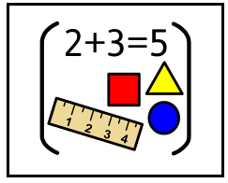 | Number and Place Value or Multiplication, Division and Fractions | Shape, Position and Direction | Number and Place Value or Addition and Subtraction | Measure | Number and Place Value or Multiplication, Division and Fractions | Time and Money
Ensure the following is delivered daily
Individualised targets taught in context from STAR Assessment

 |  | Science  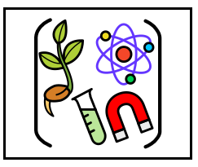 | Topic:  Forces  Intent:  Identify different types of forces (such as gravity, friction, air resistance, and applied force) | Topic:  Light  Intent:  Investigate how light travels, how it can be reflected, refracted, and absorbed. | Topic:  Sound  Intent:  Students explore the nature of sound, how it is produced, how it travels, and how it is heard. | Topic:  Earth and Space  Intent:  Develop students’ knowledge of the Earth’s place in the Solar System and to build a deeper understanding of the movements and relationships between the Earth, Moon, and Sun. | Topic:  Electricity  Intent:  Understanding of electricity, including how it is generated, how it flows through circuits, and how it powers devices in everyday life. | Topic:  Materials  Intent:  Explore a wide range of materials and understand their properties, uses, and how they can change.
Community  +  Relationships |  | World Around Us  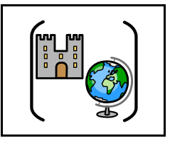 | Subject:  History  Topic:  Black History  Intent:  To deepen students' understanding of Black history, and culture, while recognising the significant contributions they have made | Subject:  Geography  Topic:  Flags  Intent:  Finding and matching | Subject:  RE  Topic:  Hinduism  Intent:  Understanding Hinduism | Subject:  History  Topic:  King and Queens  Intent:  Chronological order. | Subject:  Geography  Topic:  Seasons  Intent:  Understanding different seasons | Subject:  RE  Topic:  Judaism  Intent:  Understanding Judaism

 | PSHE   | Topic:  Friendship  Intent:  Explore the qualities of healthy, respectful, and supportive friendships. | Topic:  Responsibilities  Intent:  Understand the concept of responsibility in different aspects of their lives—at home, and at school. | Topic:  Hygiene  Intent:  Understand the importance of good personal hygiene and how it contributes to their overall health and wellbeing. | Topic:  Behaviour  Intent:  Understand what behaviour is and how it affects themselves and others | Topic:  Relationships  Intent:  Understand different kinds of relationships—like family, friends, and classmates. | Topic:  Health  Intent:  Understand what it means to be healthy—covering physical health, mental wellbeing, and healthy habits.
Health  +  Wellbeing | Music   | Topic:  Action Songs  Intent:  Mimicking or sequencing | Topic:  Finding the beat  Intent:  To follow the actions of others | Topic:  Exploring Tempo  Intent:  Understanding fast and slow | Topic:  Exploring Pitch  Intent:  Understanding high and low sounds | Topic:  Music and Movement  Intent:  To move body to a song | Topic:  Instruments and Actions  Intent:  Following instructions
Health  +  Wellbeing |  |   Primary students will have weekly music sessions delivered by the company Rhythm Time
Health  +  Wellbeing | I.T   | Topic:  Technology around us  Intent:  To explore different kinds of technology—from household gadgets to computers and communication tools. | Topic:  Digital Painting  Intent:  To explore digital tools to create artwork. | Topic:  Data  Intent:  Develop skills in collecting, organizing, and interpreting data | Topic:  Digital Writing  Intent:  Build confidence and creativity in writing using digital tools | Topic:  Logos  Intent:  What logos are and why they are important for brands and companies. | Topic:  Multimedia  Intent:  How to use different types of media, pictures, sounds, and videos—to share ideas and tell stories
Health  +  Wellbeing | Art  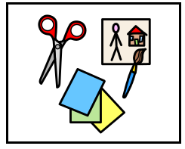 | Topic:  Abstract  Intent:  Use colours, shapes, and lines to express feelings and ideas without drawing things exactly as they look. | Topic:  Sculptures  Intent:  Making sculptures using different materials and techniques. | Topic:  Pop Art  Intent:  Learn about famous Pop artists and create their own colourful artworks using images from everyday life. | Topic:  Materials  Intent:  Students explore tools like paint, clay, pencils, to understand how they affect artwork. | Topic:  Light and Dark  Intent:  Practice using light and shadows to make drawings more realistic and interesting. | Topic:  Stephen Wiltshire  Intent:  Explore the life and artwork of Stephen Wiltshire.
Health  +  Wellbeing | PE  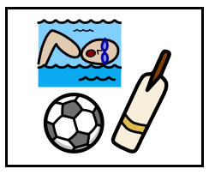 | Topic:  Jumping  Intent:  Develop their jumping skills, including balance, strength, and coordination. | Topic:  Gymnastics  Intent:  Develop strength, flexibility, balance, and coordination through gymnastics activities. | Topic:  Foot/eye coordination  Intent:  students improve their foot and eye coordination through fun and engaging activities. | Topic:  Football  Intent:  Teach students the basic skills, rules, and teamwork involved in playing football. | Topic:  Running  Intent:  Improve their running skills, including speed, endurance, and technique. | Topic:  Olympics  Intent:  Practice different physical activities inspired by the Olympics.
Health  +  Wellbeing |  |   Students access weekly dance classes and termly swimming lessons.
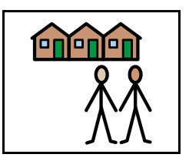  External Providers |  | - All classes will have 2 six week blocks of Forest School. The aim of these sessions is to develop, confidence and independence, empathy, physical fitness, improve physical and mental health, and improve learning. All of these sessions are planned and delivered by Fruits of the Forest.  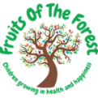    - As part of the Hippodrome Education Network (HEN) all classes have a six-week block with a Learning and Participation Artist. The aim of these sessions is to facilitate engagement in the arts whilst building confidence and resilience.

