Year 3 of 5 | Secondary |  | Autumn Term |  | Spring Term |  | Summer Term
Theme |  |  | Into the Woods | Pirates | To the Rescue | Eurovision | Splash | Journeys
Independent Living |  | My Independence  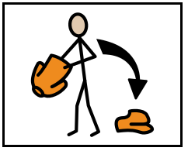 | Topic:  Shopping  Intent:  Solving problems when shopping |  | Topic:  Life Intents  Intent:  Making/receiving a phone call |  | Topic:  Travel  Intent:  Travelling on a bus
 |  | Cooking  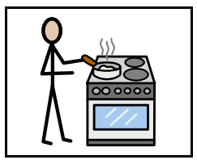 | Topic:  Life Intents  Intents:  Food safety - allergies, food poisoning, best before dates  Knife safety - recap on previous knowledge and have opportunity to practise knife skills  Weighing and measuring - recap on previous knowledge and practise skills in stand alone lesson and then as part of making cookies/cakes | Topic:  Food Around The World  Intents:  Knowledge of cultural food. Cooking food from other countries - Italy, Mexico, Caribbean, Asia | Topic:  Building Independence  Intents:  Weighing and measuring,  meal planning, shopping list, budgetting | Topic:  Cooking for a purpose  Intents:  Prepare at least 1 breakfast, lunch and dinner independently (where possible),  Easter | Topic:  Healthy Eating  Intent:  Healthy plate, Food categories, Balanced diet  P3/P4 to look at calories/energy requirements  Prepare variety of salads to practise knife skills - pasta salad, rainbow salad, fruit salad | Topic:  Healthy Eating  Intent:  Expand knowledge from Summer 1 - identify food grous for recipes followed  Cook healthy recipes - breakfast, lunch, dinner, snack
Education  +  Employment |  | Communication and  Language   | Fables/Fairy Tales | Non-Fiction/ Fact Files | Science Fiction | Poems, Songs and Rhymes | Fiction | Biographies /Autobiographies
Ensure the following is delivered daily
Reading and Writing: Individualised targets taught in the moment/in context from STAR Assessment. Listening to and reading a range of texts and poems.
Phonics: Phonics will be linked to the validated DFE phonics scheme ' Little Wandle’. Reading scheme in school ‘Big Cat’.
Speaking: Individualised targets from SCERTS and STAR Assessment
Learning will be accredited through AQA Award scheme, WJEC Entry Level or WJEC GCSE where appropriate.
 |  | Number and Problem Solving  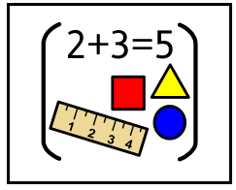 | Number and Place Value or Multiplication, Division and Fractions | Shape, Position and Direction | Number and Place Value or Addition and Subtraction | Measure | Number and Place Value or Multiplication, Division and Fractions | Time and Money
Ensure the following is delivered daily
Individualised targets taught in context from STAR Assessment
Learning will be accredited through AQA Award scheme, AQA Entry Level, AQA Functional Intents, AQA GCSE where appropriate
 |  | Science   | Topic:  Plants  Intent:  Appreciate importance of plants | Topic:  Bones  Intent:  Appreciate the role of the skeleton and muscles | Topic:  Energy  Intent:  Investigate the different forms of energy | Topic:  Sound  Intent:  Appreciate the properties of sound | Topic:  Water, Water Everywhere  Intent:  Investigate the properties of the different states of water | Topic:  Transport  Intent:  Understand issues around forms of transport
 |  | PfA and Careers  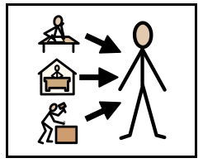 | 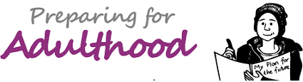    Refer to PfA timetable for overview of activities for each class.
Community  +  Relationships |  | World Around Us  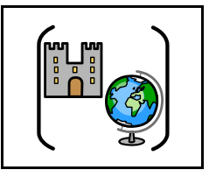 | Subject:  History  Topic:  Black History  Intent:  Knowledge of a current black person/singer/musician/popular figure | Subject:  Geography  Topic:  Flags  Intent:  Name locate and identify characteristics of the four countries. | Subject:  RE  Topic:  Hinduism  Intent:  Introduction to Hinduism and gaining further knowledge. Comparison to Sikhism. | Subject:  History  Topic:  King and Queens  Intent:  Chronological order of events. What effect of past monarchs had on our lives today? | Subject:  Geography  Topic:  Seasons  Intent:  Comparing different climates. How do these impact on human population? | Subject:  RE  Topic:  Judaism  Intent:  Introduction to Judaism and gaining further knowledge. Comparison to Christianity (Old testament)
 |  | PSHE   | Topic:  Relationships  Families & Friendship  Intent:  (Em, Am, P1, P2 )  To give pupils opportunities to explore what different families look like using stories and videos.  To create collages of their families, using photographs, drawn  images or special items. Showing what their family looks like.  To identify different family members and their roles and responsibilities.  To learn how to make positive friendships.  Bullying and how to recognise. To begin to recognise and prevent bullying.  (P2, P3)  To identify different family members and what a family is.  To identify different types of families and relationships.  To learn how to make positive friendships and  to respect ourselves and others.  To identify strategies to make and retain friendships.  Bullying and how to recognise. To begin to recognise and prevent bullying.  Topic:  Relationships  Committed relationships & Family Life.  (P4)  Intent:  (P4)  To identify different relationships that families can have across their lifetime, and the benefits of these.  To identify factors that can cause a relationship to change and why.  To recognise how young people might be affected by changes to relationships, and how they might respond to this.  To identify who young people could turn to for help and support. | Topic:  Health & Wellbeing  Emotional Wellbeing (Zones of Regulation)  (Em, Am, P1, P2, P3, P4)  Intent:  Respond with curiosity about attitudes towards mental health and emotional wellbeing.  To recognise daily wellbeing and to manage emotions | Topic:  Health & Wellbeing  Growing & Changing  (Puberty)  (Em, Am, P1, P2, P3)  Intent:  (Em, Am, P1, P2, P3)  To recognise physical and emotional changes in puberty; external genitalia; personal hygiene routines;  Topic:  Relationships  (P4)  Types of relationships  (Romantic feelings and sexual attraction)  Intent:  (P4)  To recognise romance, friendships and relationship boundaries.  To recognise Healthy/Unhealthy relationships.  Consent and the Law. | Topic:  Health & Wellbeing  Medicinal drugs, Drugs Alcohol & Medicine  (Em, Am, P1, P2, P3, P4)  Intent:  (Em, Am, P1, P2, P3)  To recognise medicines and household products; drugs common to everyday life.  Intent:  (P4)  To respond to alcohol and drug misuse and pressures relating to drug use.  Peer influence, substance use and gangs. | Topic:  Health & Wellbeing/Living in the Wider World  Keeping Safe  (Em, Am, P1, P2, P3,)  Intent:  (Em, Am, P1, P2, P3)  To recognise and identify safety in different environments.  To recognise risk and safety at home.  Emergencies.  Intent:  (P4)  To recognise and identify safe and unsafe image sharing, substance use and gang exploitation.  To recognise the influence and impact of drugs, gangs, role models and the media. | Topic:  Relationships  Safe relationships  (Em, Am, P1, P2, P3)  Intent:  (Em, Am, P1, P2, P3)  Recognise privacy; staying safe; seeking permission  Good/bad touch, Public/Private (PANTS)  Topic:  Living in the Wider World  Media Literacy & Digital resilience  (P4)  Intent:  (P4)  To identify how to keep safe and communicate safely online.  To recognise how to assess and manage risks of sending, sharing or passing on sexual images. | Topic:  Relationships  (SRE)  (P4 – Yr 9+)  Relationships and sex education including consent, contraception, the risks of sti’s and attitudes to pornography.  Intent:  To recognise and encounter positive aspects of a healthy relationship. Contraceptive choices.  STi’s and how to get help and treatment.
Health  +  Wellbeing |  | Art  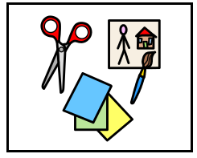 | ART  Topic:  Into the Woods…into the…?!  (eg Sea/city)  Intent:  To explore and think about Art in environments. Create human forms  Art/artist/craft:  Outdoor art – Antony Gormly – structures  Resources:  https://www.waterofleith.org.uk/art-and-attractions/antony-gormley-statues/  https://www.royalacademy.org.uk/article/antony-gormley-10-works-to-know  https://saturday-club.org/online/antony-gormley-sculpture/  - Clay, scrap materials, paper mache, photos of the pupils, Drama with photography (human form) | ART  Topic:  Viking Art  Intent:  Create Viking knots, warriors, jewellery.  Art/artist/craft:  Osberg style, The Borre style, use of animals images in artwork. | CDT  Topic:  To the Rescue  Intent:  DT – Building Bridges  - Structures  - Inc beams, trusses, engineering, materials, arches, suspension. | CDT/ ART  - textiles  - withy with tissue paper  Topic:  Eurovision  Intent:  DT – costume design – textiles - consider clothes, hats, shoes, set design (?) | ART  Topic:  Splash and Fire  Intent:  Sea Scapes and firey work! Create different 2D work exploring texture, colour and sizes of work.  Art/artist/craft:  Alfred Wallis  Resources:  Pastels  https://www.accessart.org.uk/  volcano-painting-inspired-by-frank-bowling/ | CDT/ ART  Topic:  Journeys  Intent:  DT -make model vehicles/scrap modelling
 |  | Music | Focus:  Intent: | Focus:  Intent: | Focus:  Intent: | Focus:  Intent: | Focus:  Intent: | Focus:  Intent:
 |  | PE  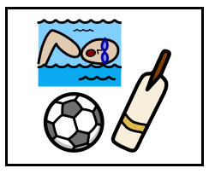 | Emerald, Amethyst, Pathway 1 will complete 2 terms of dance, 2 term at the gym,1 term at golf and 1 term at boxing. All of these activities are led by external providers and offsite.  Pathway 2, 3 and 4, will complete 4 terms at Portway leisure and 2 terms at SWIM. The activities they complete at Portway leisure will be a variety of individual and team based sports.
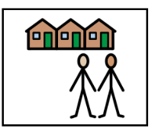  External Providers |  |  | All external providers within the secondary curriculum are linked to our PfA day which occurs weekly. The aim of PfA day is to support all of our learners to meet the long-term outcomes that have been identified as part of our carers programme. See carers programme on website.  External providers include: Forge Mill Farm, Riverside Farm, KA Equestrian Centre, Birmingham Open Media, Midland Metro Alliance, Hippodrome Education Network, Riverside House.  Classes will work with providers depending on level of need.          

ICT within the secondary curriculum is a tool for learning across all subject areas

